**React  
  
1. ReactJS-HOL**

**Step 1: Open VS Code**

* Open **Visual Studio Code**.

**Step 2: Open a Terminal in VS Code**

* Go to **Terminal > New Terminal**

**Step 4: Create a New React App**

Run this command to create a React app named myfirstreact:

**npx create-react-app myfirstreact**

**Step 5: Open the Project Folder**

After it's created, navigate into the project:

**cd myfirstreact**

**Step 6: Modify App.js**

src > App.js

function App() {

return (

<div>

<h1>Welcome to the first session of React</h1>

</div>

);

}

export default App;

**Step 7: Run the App**

**npm start**

This will start the development server and automatically open your browser to:

**http://localhost:3000**

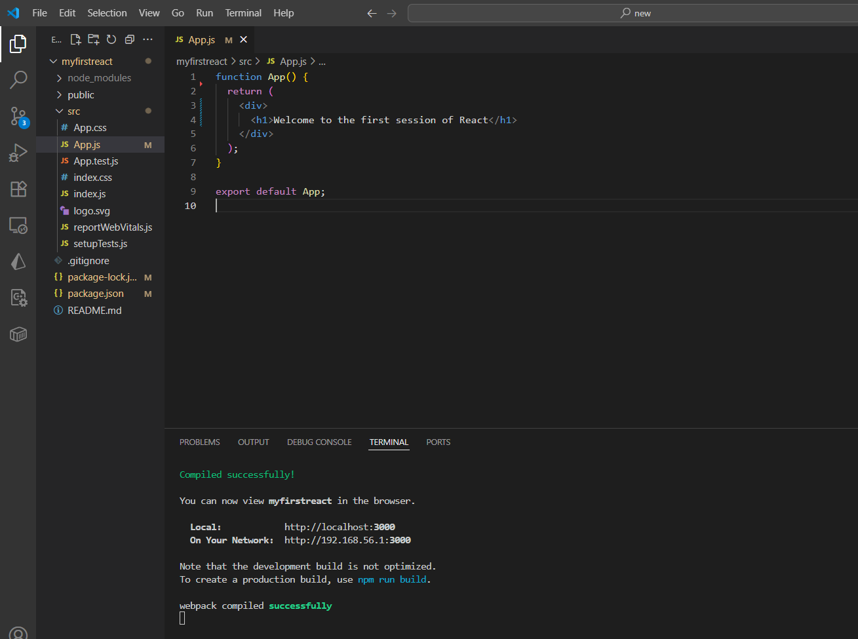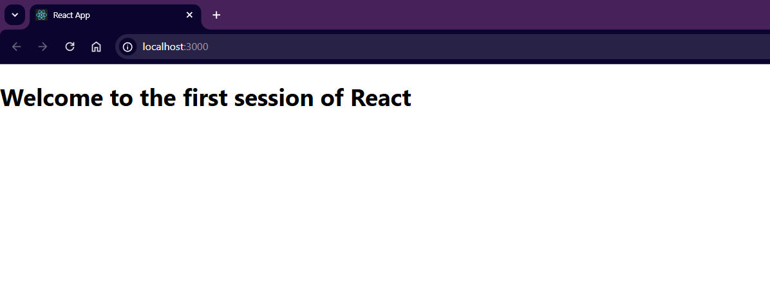

**2. ReactJS-HOL**

**Step 1: Create React Project**

In your terminal (VS Code):

**npx create-react-app StudentApp**

**cd StudentApp**

**Step 2: Create Components Folder**

In the src/ folder:

1. Right-click src > New Folder → name it Components
2. Inside Components, create these 3 files:
   * Home.js
   * About.js
   * Contact.js

**Step 3: Code for Each Component**

**Home.js**

import React, { Component } from 'react';

class Home extends Component {

render() {

return <h2>Welcome to the Home Page of Student Management Portal</h2>;

}

}

export default Home;

**About.js**

import React, { Component } from 'react';

class About extends Component {

render() {

return <h2>Welcome to the About Page of Student Management Portal</h2>;

}

}

export default About;

**Contact.js**

import React, { Component } from 'react';

class Contact extends Component {

render() {

return <h2>Welcome to the Contact Page of Student Management Portal</h2>;

}

}

export default Contact;

**Step 4: Modify App.js to Use Components**

In src/App.js, update the code like this:

import React from 'react';

import Home from './Components/Home';

import About from './Components/About';

import Contact from './Components/Contact';

function App() {

return (

<div className="App">

<Home />

<About />

<Contact />

</div>

);

}

export default App;

**Step 5: Start the App**

In your terminal:

**npm start**

Then open your browser and go to:

**http://localhost:3000**

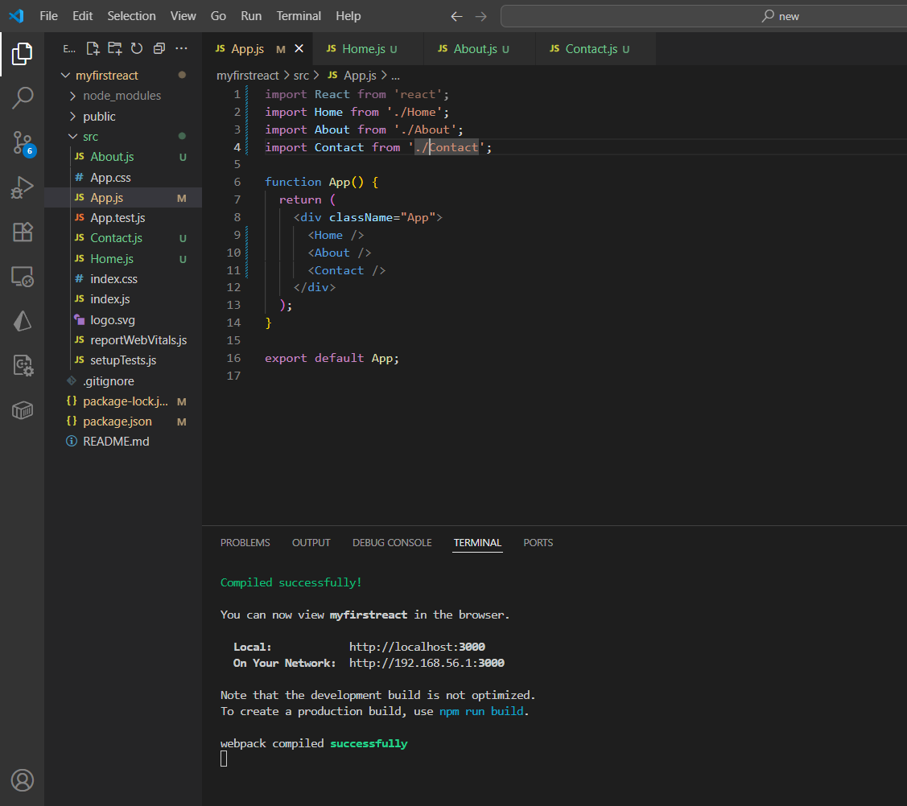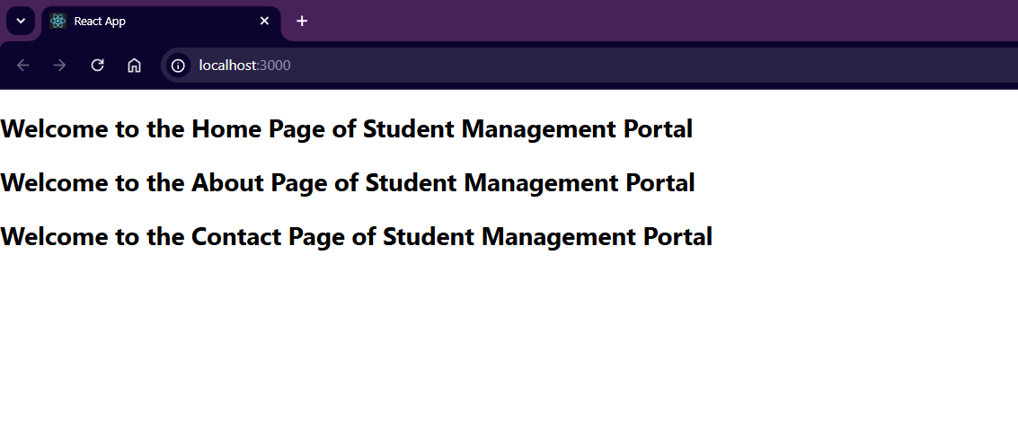

**3. ReactJS-HOL**

**Step 1: Inside src, create a folder called Components**

Create a file:  
**src/Components/CalculateScore.js**

import React from 'react';

import '../Stylesheets/mystyle.css';

function CalculateScore(props) {

const { name, school, total, goal } = props;

const score = ((total / goal) * 100).toFixed(2);

return (

<div className="main">

<h1>Student Details:</h1>

<p><span className="label">Name:</span> <span className="name">{name}</span></p>

<p><span className="label">School:</span> <span className="school">{school}</span></p>

<p><span className="label">Total:</span> {total}Marks</p>

<p><span className="label">Score:</span><span className="score">{score}%</span></p>

</div>

);

}

export default CalculateScore;

**Step 2: Create CSS file**

Inside src, create a folder Stylesheets  
**Create: mystyle.css**

.main {

text-align: center;

margin-top: 50px;

font-family: Arial, sans-serif;

}

h1 {

color: brown;

}

.label {

font-weight: bold;

}

.name {

color: blue;

}

.school {

color: crimson;

}

.score {

color: green;

}

**Step 3: Modify App.js**

Replace src/App.js content with:

import React from 'react';

import CalculateScore from './Components/CalculateScore';

function App() {

return (

<div className="App">

<CalculateScore

name="Steeve"

school="DNV Public School"

total={284}

goal={300}

/>

</div>

);

}

export default App;

**Step 4: Run the App**

In terminal:

**npm start**

Then visit:

**http://localhost:3000**  
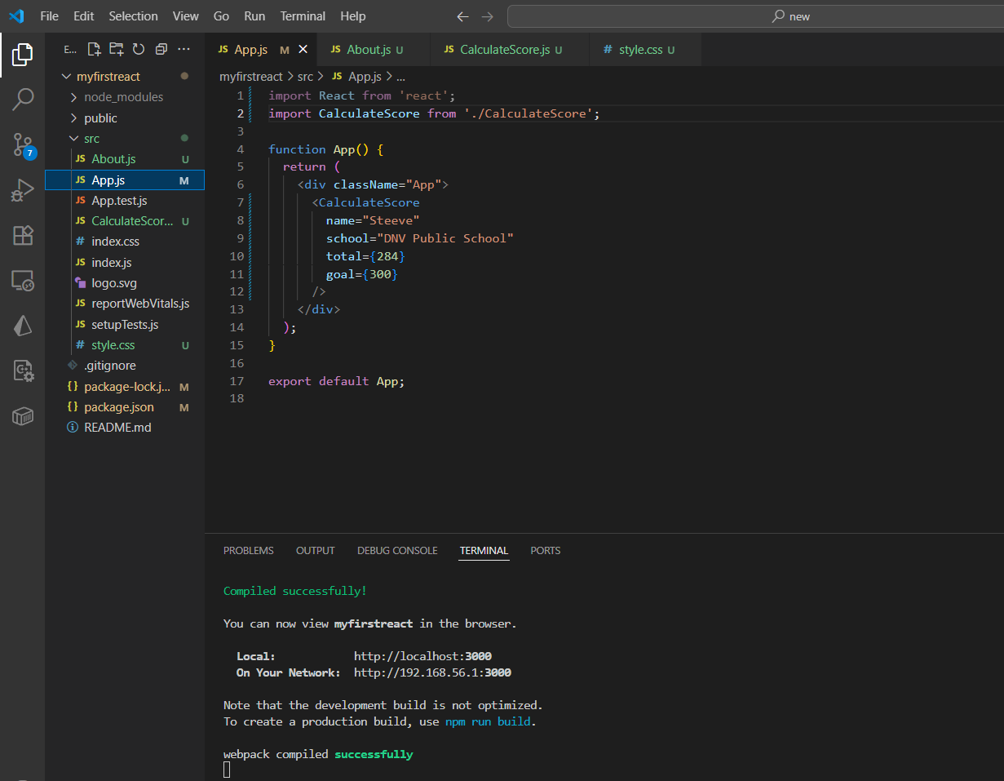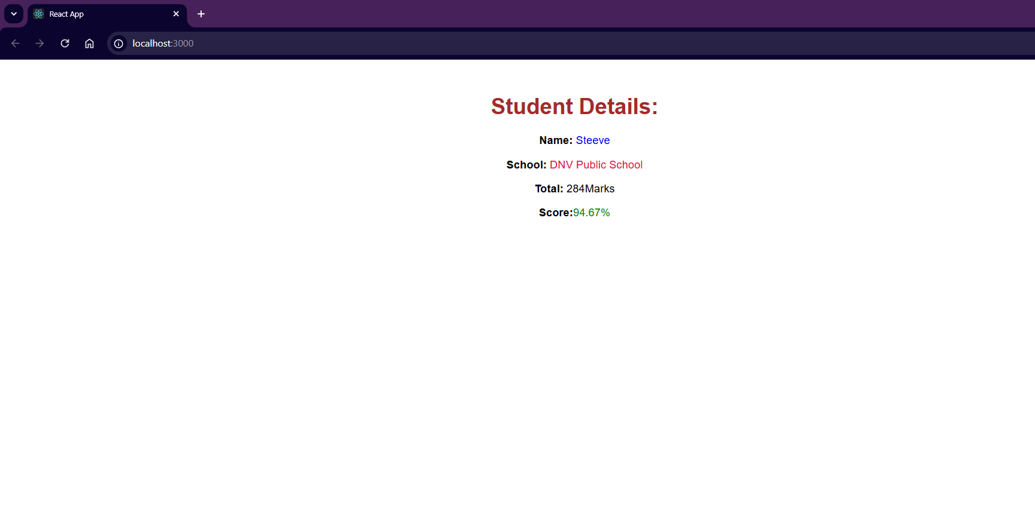

**4. ReactJS-HOL**

**Step 1: Create a React Application**

Open terminal or command prompt and run:

**npx create-react-app blogapp**

Navigate into the project folder:

**cd blogapp**

**Step 2: Create Post.js inside src/ folder**

Right-click on the **src** folder → New File → name it Post.js

Add this code inside Post.js:

class Post {

constructor(id, title, body) {

this.id = id;

this.title = title;

this.body = body;

}

}

export default Post;

**Step 3: Create Posts.js inside src/ folder**

Right-click on the **src** folder → New File → name it Posts.js

Add the basic component setup:

import React from 'react';

import Post from './Post';

class Posts extends React.Component {

constructor(props) {

super(props);

this.state = {

posts: [],

};

}

loadPosts() {

fetch('https://jsonplaceholder.typicode.com/posts')

.then((response) => response.json())

.then((data) => {

const postList = data.map(

(item) => new Post(item.id, item.title, item.body)

);

this.setState({ posts: postList });

})

.catch((error) => {

console.error("Error loading posts:", error);

alert("Error fetching posts");

});

}

componentDidMount() {

this.loadPosts();

}

componentDidCatch(error, info) {

console.log("Error:", error, "Info:", info);

alert("Something went wrong in the component.");

}

render() {

return (

<div>

<h1>Blog Posts</h1>

{this.state.posts.map((post) => (

<div key={post.id}>

<h2>{post.title}</h2>

<p>{post.body}</p>

</div>

))}

</div>

);

}

}

export default Posts;

**Step 4: Add Posts component to App.js**

Open src/App.js and update it like this:

import React from 'react';

import Posts from './Posts';

function App() {

return (

<div className="App">

<Posts />

</div>

);

}

export default App;

**Step 5: Start the Application**

In the terminal (inside your blogapp folder), run:

**npm start**

**Open a browser at http://localhost:3000/**

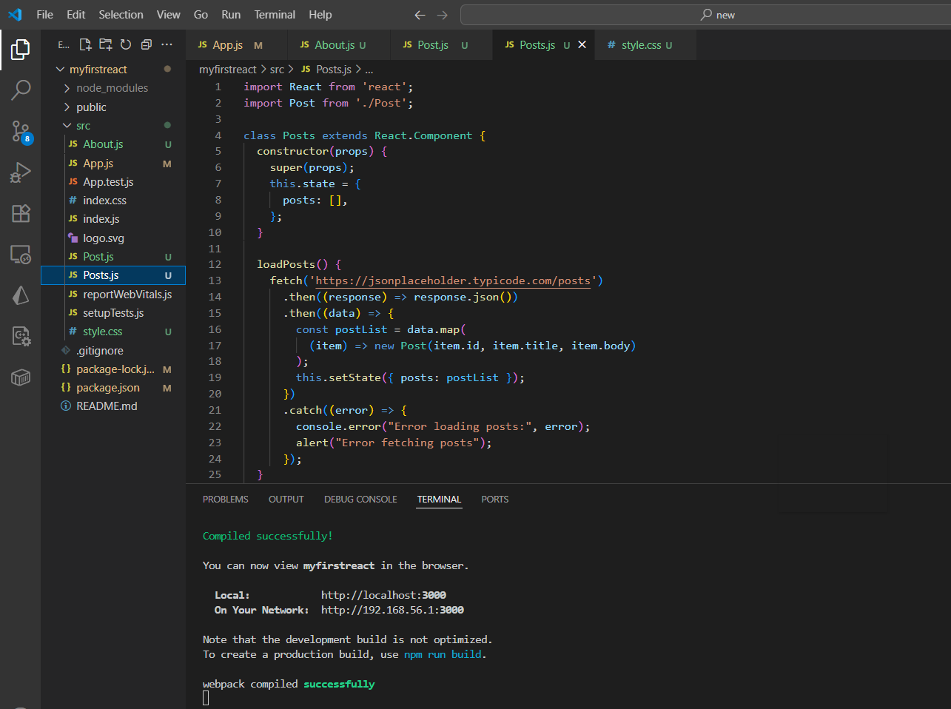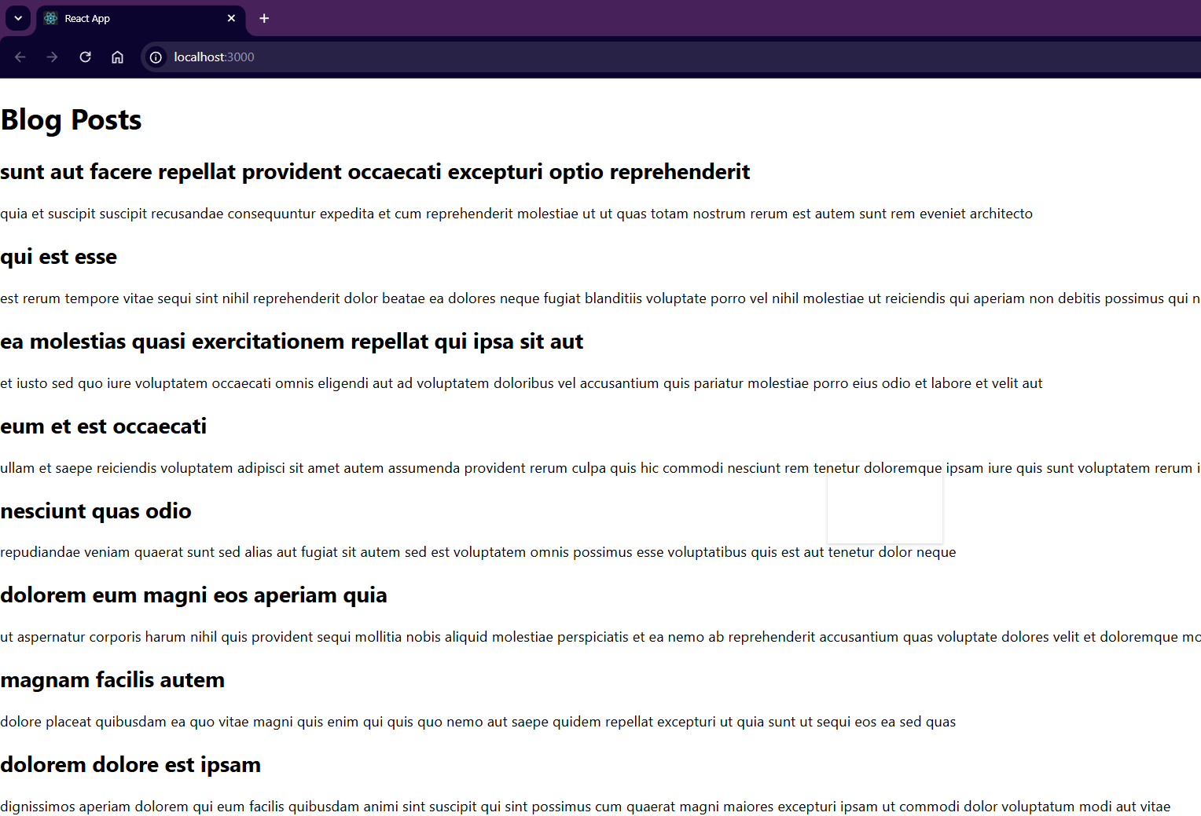

**5. ReactJS-HOL**

**Step 1: Unzip the React Application**

Unzip the cohorttracker.zip file into a folder, say:

C:\CTS-NewHandsOns\ReactHandsOns\cohorttracker

**Step 2: Restore Node Packages**

Open **Command Prompt** and navigate to the project folder:

cd C:\CTS-NewHandsOns\ReactHandsOns\cohorttracker

Install all necessary node packages:

**npm install**

This will restore all dependencies listed in package.json.

**Step 3: Create CSS Module**

Inside src folder:

1. Right-click → **New File**
2. Name it: CohortDetails.module.css

Paste the following CSS inside:

.box {

width: 300px;

display: inline-block;

margin: 10px;

padding: 10px 20px;

border: 1px solid black;

border-radius: 10px;

}

dt {

font-weight: 500;

}

**Step 4: Import the CSS Module in Component**

Open the file where cohort cards are rendered (likely something like CohortDetails.js or App.js).

At the top, import the CSS module:

**import styles from './CohortDetails.module.css';**

**Step 5: Apply CSS Module to Container**

Wrap each cohort’s content inside a <div> and apply the CSS class like this:

<div className={styles.box}>

<h3 style={{ color: cohort.status === 'Ongoing' ? 'green' : 'blue' }}>

****** </h3>

**Final Result Styling**

* Green color for Ongoing status titles
* Blue color for Scheduled or other statuses
* box class used for styling the cards
* <dt> elements styled with font weight of 500

**Step 6: Run the Application**

In the same terminal where you installed dependencies, run:

**npm start  
  
